**Using Autotune**

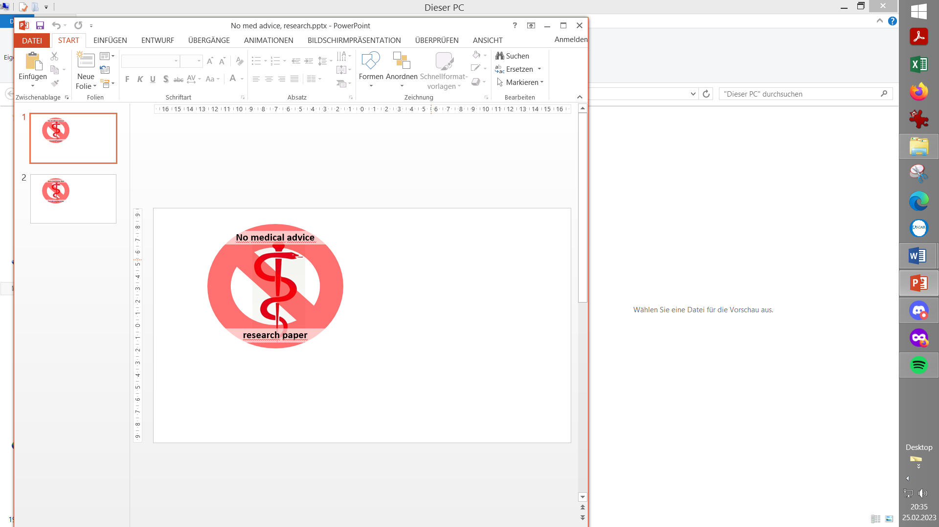

Contribution to the discussion among DIY loopers

Originally posted by Tim Street, iAPS FB Jan. 2024

More from Tim, see <https://www.diabettech.com>

1. What is Autotune (not) ?

1.1 Basal rate suggestions

1.2 ISF suggestion

1.3 Carb ratio (IC) suggestion

2. What does it mean ?

2,1. General limitations

2.2 Specific implication if using dynamicISF

3. Further remarks

3.1 Periods with cartbs matter

3.2 How to turn a ISFsuggestion into an ISF profile

3.3 UAM implications (steady rising basal?)

1. **What is Autotune**

Let's start with what it's not. It is not Machine Learning. It is not AI.

It is a statistical regression attempting to compare

* what happened over the last 24 hours with what profile settings are,
* then, adjust the profile settings accordingly (for improved result)

1.1 Basal rate suggestions

For basals, it divides the day into hour long increments.

* It calculates the total deviations for that hour increment
* and calculates what change in basal would be required to adjust those deviations to 0.

It then applies 20% of that change needed to the three hours prior (because of insulin impact time).

If increasing basal, it increases each of the 3 hour increments by the same amount.

If decreasing basal, it does so proportionally, so the biggest basal is reduced the most.

* 1. ISF suggestions

For ISF

* it calculates the 50th percentile (median) deviation for the entire day
* and determines how much ISF would need to change to get that deviation to 0.

It applies 10% of that as an adjustment to ISF.

1.3 IC (carb ratio) suggestions

For IC

* it calculates the total deviations over all of the day’s mealtimes
* and compares to the deviations that are expected based on existing CR and the known amount of carbs entered.

It applies 10% of that adjustment to IC.

1. **What does it mean?**

Autotune uses Deviations to calculate basal variation. It does so by using a profile based ISF value.

* 1. General limitations

It can only run with a single daily ISF and CR.

* As a result, it doesn't work for most people who, for a good reason, go with multiple ISFs and ICs over 24 hours in their set profile.
  1. Specific implications if using dynamicISF

This means that if you enable Autotune, but use Dynamic functions within iAPS, it will not be using the ISF that was in operation at the time of the loop running in the past, and basal adjustments are likely to be incorrect, as well as ISF adjustments.

* Don't use Autotune if you use Dynamic functions. The results will at best be unreliable

1. **Some further remarks**

3.1 Periods with and without cob matter Co-author. Philoul March.23

Autotune analyses and categorizes your data to tune your profile. In a nutshell

* all data **with cob** (grey dev bars) will be used to tune **IC** only
* data **without COB** will be used to tune either **basal** (if IOB is below a threshold) **or ISF** value.

So if you have very few periods without COB you can have not enough data to tune correctly ISF and basal.

Plus, if ISF is not correctly tuned, then this will trouble also the IC tuning (everything is linked together; the loop needs all the profile parameters to calculate effects)...

Another important point in this context is, that for Autotune evaluations,, the starting and ending hour is always 4 AM. In case there is not COB=0 at 4 AM, the previous day will be ignored in Autotune calculation for IC, and the remaining cob at 4AM will be ignored in caregorization of following day... This will not have a huge impact on autotune results if it's not too often, but if it's often your results can be wrong...

3.2 How to turn a ISF suggestion into profile ISFs Co-author Bernie, Jan.24

The limitations pointed to at section 2.1 about getting only one single ISF suggestion can be partially overcome as follows:

* Easiest to do would be to calculate the new ISF / old ISF sensitivity change that is suggested. Whereby the old ISF is the one from the previous Autotune run.
* Or, you would have to calculate an old average from the 24hr old pattern. (Perfectionists might want to look into whether it makes sense to put emphasis on hours where actually the loop makes major use of ISF, by issuing SMBs, for instance).
* Then apply tis %sensitivity change to the entire old profile.
* Same can be done to IC, and for basal Autotune already gives a new pattern. (Perfectionists could further analyze, whether the new one deviates stroinger from a circadian pattern you might have had before, and whether you want to maintain this by, also for basal, going with a factor (new total 24 h basal) / (old 24 h basal) to convert all old hourly basal values into the new ones, in the desired circadian pattern)..

In AAPS Users FB /Files is a xls-based calculation scheme where you might be able to turn your old profile and new Autotune input into a new profile. https://www.facebook.com/groups/AndroidAPSUsers/permalink/2869638923257506/(by: F. Düsterhöft) - Note: I have not used this xls for years. It may need an update)

It includes references to Nauck vs. Scheiner regarding suggested circadian patterns.

One nice extra feature it offers is an entry field for your going-to-sleep time (how that should changes your profile pattern.

In AAPS/Profile switch, there is a time shift entry field that will do the same for you.

If basal, ISF and IC change by the same % in the Autotune suggestion, you could in AAPS also just clone a new profile with that that %age applied. (But, often, Autotune suggests basal changes very differently from ISF and IC regarding what underlying sensitivity change you could pin to it).

3.3 UAM and Autotune: Steady rising basal? (observations reported March ‘23)

(Bernie). -My personal experience (years ago) with a couple of months using Autotune had been that it kept elevating my basal, and in turn my factors went softer. Over time I noticed, that was not good for my overall loop performance. I stopped using Autotune, and did fairly much a re-set to my original profile (that was “experimentally”, like in Open Loop, established before). My suspicion is that my very rough, if not missing, carb inputs hav to do with that.

(emmatovar27) I have used AutoTune with UAM. It works as a reference for basal and ISF. Since it doesn't have a carb entry it doesn't tune your IC.

(Tim Street) What generally happens is that if you rely completely on the UAM functionality, prior to UAM classification of deviations, you get a number of relatively high deviations that are attributed to basal being incorrect, so it has a tendency to steadily increase your basal, which obviously also affects the profile ISF value